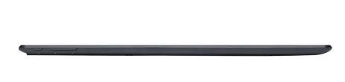


Stage
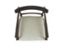











































































































































































































































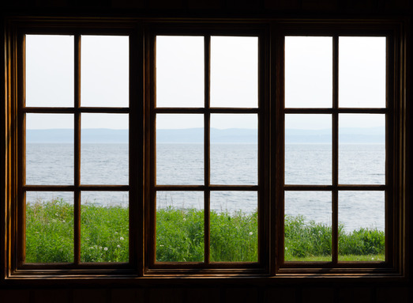



6 x 9
6 x 9 (+ 5)
7 x 11
4 x 1
4 x 1
2 x 9
2 x 10
Closet
Sound booth

